Assignment Brief
Unit 02 Develop aspects of physical fitness for entry to the uniformed services
Task 2: Submission Deadline - 18/11/20 |  | Unit Criteria:
You are required to design and produce a training programme for yourself.  You must:  - identify own level of physical fitness in relation to a uniformed service’s physical activity standards  - explore methods of achieving physical fitness to meet the entry standards of a uniformed service.  Learners must measure levels of physical fitness in relation to uniformed services standards. The learner will need to undergo fitness assessment using fitness tests used by uniformed services such as bleep test, 1.5 mile run, press-ups and sit-ups, etc. They will identify development needs and design a fitness log and training programme to achieve or maintain the required standard of physical fitness. This should be a minimum of 6 weeks, and reviewed at the end of each week.  The training programme should include:  - rest days  - facilities and resources  - embedding sport (eg football, rugby, etc)  - types of training (eg cardiovascular, etc)  - creating and utilising their fitness diary  - wearable technology, such as apps, heartrate monitors, GPS  - targets (set by the original fitness log – principles of fitness)  - a risk assessment.  The learner must include correct training techniques with regards to health and safety requirements in the training programme.  Evidence must include:  - fitness log  - physical training programme  - fitness level standards for a chosen uniformed service  - personal fitness assessments  - health and safety risk assessments  - personal fitness targets.  Evidence could include:  - blog  - journal  - schedule.  Pass: You will design your own training and fitness plan, with goals. You will complete this training programme showing your results  Merit: You will design your own training and fitness plan, with goals. You will complete this training programme showing your results, including explanations of results and exercises  Distinction: You will design your own training and fitness plan, with goals. You will complete this training programme showing your results, including explanations of results and exercise, with links to videos explaining exercises.  Report – Submitted Via Turn It In TEAMS. |  | LO2

Assignment title | Planning a health related physical activity programme  service
Purpose of this assignment: In this unit, you will look at a variety of factors associated with health and fitness including: the major body systems and how they are affected by diet and exercise; the key components of nutrition and diet and the fitness tests you need to undertake and pass if you are going to be successful in being recruited to the uniformed public services.
Scenario: As a consequence of your recent fitness results and on the guidance given by a public service recruitment team on the fitness entry requirements needed to enter a public service, this has prompted you to design your own training programme. The information you were given by your local recruiting office, was to research certain case studies of various individuals to make you aware and enable you to reflect on your own health and fitness goals prior to joining the public service of your choice, with the aim of making you fully prepared of completing and succeeding a fitness test in the public services to gain entry.

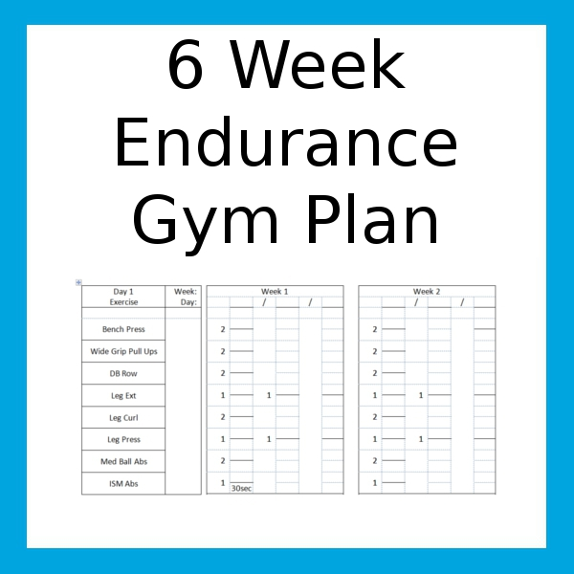

Assignment Guidance Task 2:  Task – You are to plan and take part in a 6-week training programme incorporating the principles of training based on personal fitness test results.  Your plan should include realistic activities (ones you will actually do). You should show how you are planning overload and progression into your programme. What type of exercise is needed (i.e.-CV, Resistance machines, circuit training and flexibility training? You also need to mention how many sets and reps, weight kg? How much time spent doing exercise. Show variety in your training to avoid boredom.  The service you want to join may be different from others in your tutor group. Don’t be concerned about this, your training programme is likely to be very different from people who want other services. Don’t be tempted to do the same as they do because it is easier than designing your own training programme. Remember you are getting yourself ready for your service, for example following a training programme for a police fitness test wouldn’t be much help if you want to be in the HM Forces. | P5, M4, P6  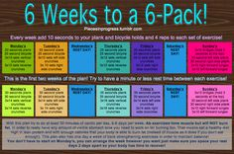
Sources of Information - Indicative reading for learners
Textbooks -
Gray, D. (2014) BTEC First Public Services: Student Book, Harlow: Pearson Education, ISBN 978 1 44691 081 8.
Websites
The British Army: www.army.mod.uk, The British Transport Police: www.btp.police.uk The Fire Service: www.fireservice.co.uk Her Majesty’s Revenue & Customs: www.hmrc.gov.uk The Ministry of Defence: www.gov.uk/government/organisations/ministry-of-defence The Prison Service: www.gov.uk/government/organisations/hm-prison-service The Royal Air Force: www.raf.mod.uk The Royal Navy and Royal Marines: www.royalnavy.mod.uk Civil service careers: www.civilservice.gov.uk/recruitment NHS careers: www.nhscareers.nhs.uk Public services recruitment agency: www.jobsgopublic.com Public sector jobs at Reed recruitment agency: www.reed.co.uk/public
Main Employability Skills You Will Develop From This Assignment
Accept responsibility, Appropriate assertiveness
Monitor & evaluate performance | ✓
Goal setting | ✓
Punctuality
Asking for help
Self-control | ✓
Reliability
Presentation
Overcome challenges | ✓
Reflect on learning | ✓
Take constructive feedback
Demonstrating flexibility | ✓
Using initiative | ✓

